COURSE: CSA1715-Artificial Intelligence Name: Siva Balan K
DATE: 14.07.2026 Reg.no: 192572037

EXPERIMENT 1: Write a python program to solve 8-Puzzle Problem

Aim
To solve the 8-Puzzle problem using the A* Search Algorithm with the Manhattan Distance heuristic.

Algorithm
Step 1: Start the program.
Step 2: Read the initial state and goal state from the user.
Step 3: Store the goal positions of all tiles.
Step 4: Calculate the Manhattan Distance heuristic for the current state.
Step 5: Find the position of the blank tile.
Step 6: Generate all possible neighboring states by moving the blank tile.
Step 7: Apply the A* Search algorithm to explore the state with the minimum cost.
Step 8: Continue generating states until the goal state is reached.
Step 9: Display the sequence of moves from the initial state to the goal state.
Step 10: Stop the program.

Program

import heapq

# Dictionary to store goal positions
goal_pos = {}

# Heuristic Function (Manhattan Distance)
def heuristic(state):
distance = 0
for i in range(3):
for j in range(3):
value = state[i][j]
if value != 0:
x, y = goal_pos[value]
distance += abs(i - x) + abs(j - y)
return distance

# Find blank tile
def find_blank(state):
for i in range(3):
for j in range(3):
if state[i][j] == 0:
return i, j

# Generate neighboring states
def get_neighbors(state):
neighbors = []
x, y = find_blank(state)

moves = [(-1, 0), (1, 0), (0, -1), (0, 1)]

for dx, dy in moves:
nx, ny = x + dx, y + dy

if 0 <= nx < 3 and 0 <= ny < 3:
new_state = [row[:] for row in state]
new_state[x][y], new_state[nx][ny] = new_state[nx][ny], new_state[x][y]
neighbors.append(new_state)

return neighbors

# Convert state to tuple
def state_to_tuple(state):
return tuple(tuple(row) for row in state)

# A* Search Algorithm
def solve(initial, goal):
open_list = []
visited = set()

heapq.heappush(open_list, (heuristic(initial), 0, initial, []))

while open_list:
f, g, current, path = heapq.heappop(open_list)

if current == goal:
return path + [current]

current_tuple = state_to_tuple(current)

if current_tuple in visited:
continue

visited.add(current_tuple)

for neighbor in get_neighbors(current):
if state_to_tuple(neighbor) not in visited:
heapq.heappush(
open_list,
(
g + 1 + heuristic(neighbor),
g + 1,
neighbor,
path + [current],
),
)

return None

# ---------------- MAIN PROGRAM ----------------

print("========== 8-Puzzle Solver ==========")
print("Leave the blank tile empty.")
print("Example:")
print("Row 1: 1,2,3")
print("Row 2: 4,,6")
print("Row 3: 7,5,8\n")

# Initial State
print("Enter Initial State:")
initial = []

for i in range(3):
while True:
row = input(f"Row {i+1}: ").split(",")
if len(row) == 3:
row = [0 if x.strip() == "" else int(x) for x in row]
initial.append(row)
break
else:
print("Please enter exactly 3 values separated by commas.")

# Goal State
print("\nEnter Goal State:")
goal = []

for i in range(3):
while True:
row = input(f"Row {i+1}: ").split(",")
if len(row) == 3:
row = [0 if x.strip() == "" else int(x) for x in row]
goal.append(row)
break
else:
print("Please enter exactly 3 values separated by commas.")

# Store goal positions
for i in range(3):
for j in range(3):
goal_pos[goal[i][j]] = (i, j)

# Solve the puzzle
solution = solve(initial, goal)

# Display Result
if solution:
print("\nSolution Found!")
print("Number of Moves:", len(solution) - 1)

for step, state in enumerate(solution):
print(f"\nStep {step}")
for row in state:
print([" " if x == 0 else x for x in row])
else:
print("\nNo solution exists.")

Output

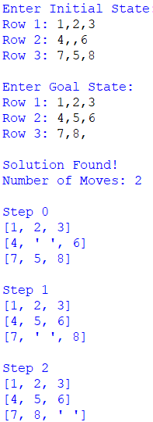

Result
Thus, the 8-Puzzle problem was successfully solved using the A Search Algorithm*, and the sequence of moves from the initial state to the goal state was obtained successfully.

EXPERIMENT 2: Write a python program to solve 8-queen problem

Aim
To solve the N-Queen (8-Queen) problem using the Backtracking Algorithm.

Algorithm
Step 1: Start the program.
Step 2: Read the number of queens N from the user.
Step 3: Initialize an empty chessboard.
Step 4: Place a queen in the first row.
Step 5: Check whether the current position is safe.
Step 6: If safe, place the queen and move to the next row.
Step 7: If not safe, try the next column.
Step 8: If no column is safe, backtrack to the previous row.
Step 9: Repeat the process until all queens are placed.
Step 10: Display the chessboard containing the solution.
Step 11: Stop the program.

Program
def print_board(board, n):
print("\nSolution:\n")
for i in range(n):
for j in range(n):
if board[i] == j:
print("Q", end=" ")
else:
print(".", end=" ")
print()

def is_safe(board, row, col):
for i in range(row):
# Check same column
if board[i] == col:
return False

# Check left diagonal
if board[i] - i == col - row:
return False

# Check right diagonal
if board[i] + i == col + row:
return False

return True

def solve(board, row, n):
if row == n:
return True

for col in range(n):
if is_safe(board, row, col):
board[row] = col

if solve(board, row + 1, n):
return True

board[row] = -1

return False

# ---------------- MAIN PROGRAM ----------------

n = int(input("Enter the number of Queens: "))

board = [-1] * n

if solve(board, 0, n):
print_board(board, n)
else:
print("No solution exists.")

Output
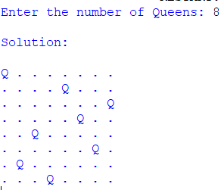

Result
Thus, the 8-Queen Problem was successfully solved using the Backtracking Algorithm, and a valid arrangement of queens was obtained.

EXPERIMENT 3: Write a python program to water jug problem

Aim
To solve the Water Jug Problem using the Breadth-First Search (BFS) algorithm.

Algorithm
Step 1: Start the program.
Step 2: Read the capacities of Jug 1 and Jug 2.
Step 3: Read the target amount.
Step 4: Initialize the initial state as (0, 0).
Step 5: Generate all possible states by filling, emptying, or pouring water between the jugs.
Step 6: Mark visited states to avoid repetition.
Step 7: Repeat the process using Breadth-First Search until the target amount is obtained.
Step 8: Display the sequence of steps.
Step 9: Stop the program.

Program
from collections import deque

# Function to solve Water Jug Problem using BFS
def water_jug_bfs(jug1, jug2, target):

visited = set()
queue = deque()

# Initial state (0,0)
queue.append((0, 0, []))

while queue:
x, y, path = queue.popleft()

if (x, y) in visited:
continue

visited.add((x, y))
path = path + [(x, y)]

# Check if target is reached
if x == target or y == target:
return path

# Possible next states
next_states = [

# Fill Jug 1
(jug1, y),

# Fill Jug 2
(x, jug2),

# Empty Jug 1
(0, y),

# Empty Jug 2
(x, 0),

# Pour Jug 1 -> Jug 2
(max(0, x - (jug2 - y)), min(jug2, x + y)),

# Pour Jug 2 -> Jug 1
(min(jug1, x + y), max(0, y - (jug1 - x)))
]

for state in next_states:
if state not in visited:
queue.append((state[0], state[1], path))

return None

# ---------------- MAIN PROGRAM ----------------

print("========== Water Jug Problem ==========\n")

jug1 = int(input("Enter the capacity of Jug 1: "))
jug2 = int(input("Enter the capacity of Jug 2: "))
target = int(input("Enter the target amount: "))

solution = water_jug_bfs(jug1, jug2, target)

if solution:
print("\nSolution Found!\n")
print("Steps:")

for step, state in enumerate(solution):
print(f"Step {step}: Jug1 = {state[0]} L, Jug2 = {state[1]} L")

else:
print("\nNo solution exists.")

Ouput
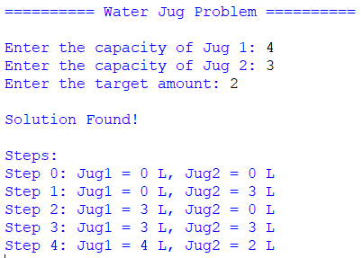

Result
Thus, the Water Jug Problem was successfully solved using the Breadth-First Search (BFS) algorithm, and the required target amount was obtained.

